**Test Case A ,B ,C ,D and E**

|  |  |  |  |  |
| --- | --- | --- | --- | --- |
| No | Scenario | Input | Output | Pass / Fail |
| 1 | Day Validation | 21 | Ask the user for a day if its valid it moves for Month | Pass |



|  |  |  |  |  |
| --- | --- | --- | --- | --- |
| No | Scenario | Input | Output | Pass / Fail |
| 2 | Day Validation (handling invalid inputs) | Hello | Error Massage will pop and ask the user to input a valid date again | Pass |

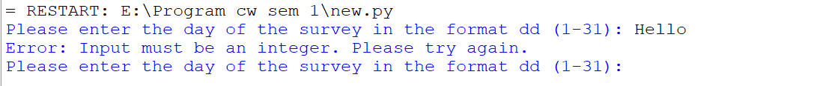

|  |  |  |  |  |
| --- | --- | --- | --- | --- |
| No | Scenario | Input | Output | Pass / Fail |
| 3 | Month Validation | 6 | Ask the user for a Month if its valid it moves for Year | Pass |



|  |  |  |  |  |
| --- | --- | --- | --- | --- |
| No | Scenario | Input | Output | Pass / Fail |
| 4 | Month Validation (handling invalid inputs) | World | Error Massage will pop and ask the user to input a valid Month again | Pass |



|  |  |  |  |  |
| --- | --- | --- | --- | --- |
| No | Scenario | Input | Output | Pass / Fail |
| 5 | Year Validation | 2024 | Ask the user for a year if its valid it prints the CSV Filename | Pass |

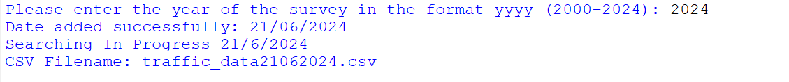

|  |  |  |  |  |
| --- | --- | --- | --- | --- |
| No | Scenario | Input | Output | Pass / Fail |
| 6 | Year Validation (handling invalid inputs) | Year | Error Massage will pop and ask the user to input a valid Year again | Pass |



|  |  |  |  |  |
| --- | --- | --- | --- | --- |
| No | Scenario | Input | Output | Pass / Fail |
| 7 | Input Validation (Range Handling) | Day, Month and Year | Massage will pop and let the user know that the input date is out of range | Pass |

|  |  |  |  |  |
| --- | --- | --- | --- | --- |
| No | Scenario | Input | Output | Pass / Fail |
| 8 | If the given date is not found | Day, Month and Year | Massage will pop and let the user know that the input date is not available | Pass |

|  |  |  |  |  |
| --- | --- | --- | --- | --- |
| No | Scenario | Input | Output | Pass / Fail |
| 9 | Printing Outcomes | Proper Day, Month and Year | Displays all the Outcomes after a proper calculation | Pass |

|  |  |  |  |  |
| --- | --- | --- | --- | --- |
| No | Scenario | Input | Output | Pass / Fail |
| 10 | Saving in a Text file | Proper Day, Month and Year | Save all the results in a text file | Pass |

|  |  |  |  |  |
| --- | --- | --- | --- | --- |
| No | Scenario | Input | Output | Pass / Fail |
| 11 | Generating Histogram | Proper Day, Month and Year (availability of the file) | Histogram Window | Pass |

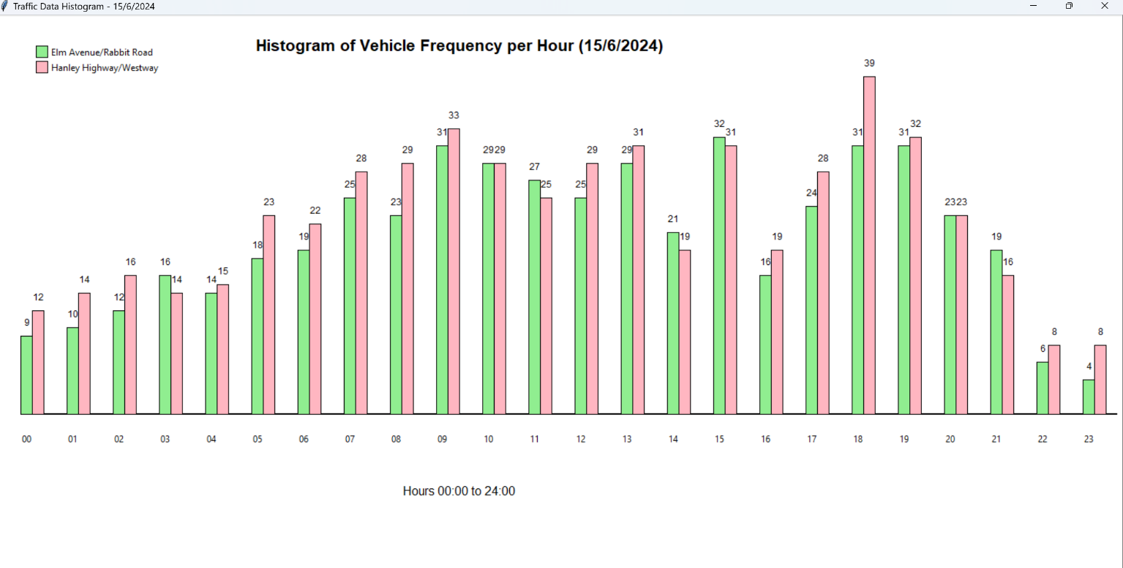

|  |  |  |  |  |
| --- | --- | --- | --- | --- |
| No | Scenario | Input | Output | Pass / Fail |
| 12 | If date is not availability | Proper Day, Month and Year ( within the range ) | Proper error massage and ask the user to run the program | Pass |

|  |  |  |  |  |
| --- | --- | --- | --- | --- |
| No | Scenario | Input | Output | Pass / Fail |
| 13 | Handling Multiple files | Proper Day, Month and Year | After closing the histogram it will ask the user to loop or exit | Pass |

